1449/1 & 2

Matematik
Kertas 1/2
2019

JABATAN PELAJARAN TERENGGANU

MPP 3 / TAHUN 2019

SIJIL PELAJARAN MALAYSIA

MATEMATIK 1449/1/2

Kertas 1 & 2

PERATURAN PEMARKAHAN

Markah = $\frac{\text{Kertas}1+\text{Kertas}2}{\text{140}}$x 100

Peraturan Pemarkahan ini mengandungi 16 halaman bercetak

Disediakan oleh : Guru AKRAM Negeri Terengganu

SKEMA PERMARKAHAN

MPP 3 / TAHUN 2019

SIJIL PELAJARAN MALAYSIA

MATEMATIK KERTAS 1

1 | C | 11 | D | 21 | C | 31 | A
2 | B | 12 | D | 22 | B | 32 | D
3 | C | 13 | B | 23 | C | 33 | B
4 | C | 14 | C | 24 | D | 34 | A
5 | B | 15 | B | 25 | B | 35 | D
6 | A | 16 | D | 26 | D | 36 | A
7 | A | 17 | C | 27 | C | 37 | B
8 | C | 18 | A | 28 | C | 38 | D
9 | B | 19 | A | 29 | B | 39 | A
10 | B | 20 | C | 30 | D | 40 | C

MATEMATIK KERTAS 2

Bahagian A

Soalan | Peraturan Pemarkahan | Markah
1 | -1  4  3  2  5  -2  -1  0  1  5  1  2  3  4  x  y | K1  P2 | 3
2 | ∠MNP atau ∠PNM  Tan θ = atau setara  26.6° atau 26.57° atau 26°34’ | P1  K1  N1 | 3

Soalan | Peraturan Permarkahan | Markah
3 |  | K1  K1  N1N1 | 4
4 | or equivalent  –  302.17 or or | K1  K1  K1  N1 | 4
5 | x = 3  y = −2 | K1  K1  N1  N1 | 4
6(a)  (b)  (c) | Some/Sebilangan  If Set A has 3 elements then it has 8 subsets  Jika Set A mempunyai 3 unsur, maka Set A mempunyai 8 subset  If Set A has 8 subsets the it has 3 elements  Jika Set A mempunyai 8 subset, maka Set A mempunyai 3 unsur  2 + 2n  n = 0, 1, 2, 3, …  or ( 1 + n )  ( n = 0, 1, 2, 3, …)  or ( 2n )  ( n = 1, 2, 3, 4…)  or equivalent | P1  P1  P1  K1  K1 | 5
Soalan | Peraturan Permarkahan | Markah
7 (a)  (b) | x-intercept = 18 | P1  K1  N1  K1  N1 | 5
8 | $\text{20}p+\text{12}q=\text{402}$  $\text{23}p+\text{14}q=\text{465}$  $$\left(\begin{matrix}\text{20} & \text{12} \\ \text{23} & \text{14}\end{matrix}\right)\left(\begin{matrix}p \\ q\end{matrix}\right)=\left(\begin{matrix}\text{402} \\ \text{465}\end{matrix}\right)$$  $\left(\begin{matrix}p \\ q\end{matrix}\right)=\frac{1}{(\text{20})(\text{14})−(\text{12})(\text{23})}\left(\begin{matrix}\text{14} & −\text{12} \\ −\text{23} & \text{20}\end{matrix}\right)\left(\begin{matrix}\text{402} \\ \text{465}\end{matrix}\right)$ or  $$\left(\begin{matrix}p \\ q\end{matrix}\right)=\begin{aligned}\left(\text{Inverse} | \right) \\ \end{aligned}$$  p = 12  q = 13.5  Notes:  - Do not accept $\begin{aligned}\left(\text{Inverse} | \right) \\ \end{aligned}$ or $\begin{aligned}\left(\text{Inverse} | \right) \\ \end{aligned}$  - $\left(\begin{matrix}x \\ y\end{matrix}\right)=\left(\begin{matrix}\text{12} \\ \text{13}\text{.}5\end{matrix}\right)$ as final answer, award N1  - Do not accept any solution solved not using matrix method. | P1  P1  P1  K1  N1  N1 | 6
Soalan | Peraturan Permarkahan | Markah
9 (a)  (b) | or  + + 14 + 7 + 7  or or 53.67  or or 7 x 7  or or 117.83 | K1  K1  N1  K1  K1  N1 | 6
10 (a)  (b) | S = {(A,B), (A,C), (A,D), (A,E), (B,A), (B,C), (B,D), (B,E),  (C,A), (C,B), (C,D), (C,E), (D,A), (D,B), (D,C), (D,E),  (E,A), (E,B), (E,C), (E,D)}  Note : Allow two mistakes for P1  i) {(A,D), (A,E), (B,D), (B,E), (C,D), (C,E), (D,A), (D,B),  (D,C), (D,E), (E,A), (E,B), (E,C), (E,D)}  P(A) = $\frac{\text{14}}{\text{20}}$ or $\frac{7}{\text{10}}$  ii) {(A,D), (A,E), (B,D), (B,E), (C,D), (C,E), (D,A), (D,B),  (D,C), (E,A), (E,B), (E,C)}  P(A) = $\frac{\text{12}}{\text{20}}$ or $\frac{3}{5}$ | P2  K1  N1  K1  N1 | 6
Soalan | Peraturan Permarkahan | Markah
11 (a)  (b)  (c) | 20  Notes:  T = 50 | P1  K1  N1  K2  N1 | 6

Bahagian B

Soalan | Peraturan Permarkahan | Markah
12 (a)  (b)  (c)(i)  (ii)  (d) | y = 5 ,  y = ‒25  Graph :  Axis drawn in correct directions with uniform scales for – 4 x 3.5  All 7 points and *2 points correctly plotted or curve passes through all the points for – 4 x 3.5.  Note:  - 8 or 7 points correctly plotted, award K1  - Ignore curve out of range.  Smooth and continuous curve without any straight line passing through all 9 correct points using the given scales for – 4 x 3.5  6 y 7  2.4 x 2.6  Straight line y = ‒10 ‒ 4x correctly drawn.  (Checked any two points plotted or straight line passes through any two of the (‒1, ‒6), (0, ‒10) (2, ‒18),… accurate to $±\frac{1}{2}$ square grid vertically)  Note:  Identify equation $y=−\text{10}−4x$award K1  $−2\text{.}8 ≤ x ≤ −2\text{.}6$  $2\text{.}6 ≤ x ≤ 2\text{.}8$  NOTE:  1. Allow P mark or N mark if values of x and y are shown on graph  2. Values of x and of y obtained by calculations, award P0 or N0.  3. Values of x and of y obtained from wrong graph, award P0 | K1  K1  P1  K2  N1  P1  P1  K2  N1  N1 | 2  4  2  4  12

Graph for Question 12/Graf untuk Soalan 12

O

‒5

‒10

5
– 2
– 1 -1
‒15

– 3
1
2
3
– 20
– 25
– 30
x
y
10
15
– 35
4
– 4

Soalan | Peraturan Permarkahan | Markah
13(a)(i)  (ii)  (b)(i) | (4, 9)  Note:  (4, 9) marked on diagram or (6, 1) seen or (6, 1) marked on diagram, award P1.  (6, 5)  Note :  (6, 5) marked on the diagram or (3, 6) seen or (3, 6) marked on diagram, award P1  (a) U = Reflection in the line y = 6 // Pantulan pada garis y = 6.  Note:  Reflection // Pantulan, award P1  (b) V = Enlargement, scale factor $\frac{1}{2}$, centre E (1, 5) //  Pembesaran, faktor skala $\frac{1}{2}$, pada pusat E (1, 5)  Note:  - Enlargement, scale factor 2 // Pembesaran, faktor skala $\frac{1}{2}$, award P2  - Enlargement, centre E (1, 5) // Pembesaran, pada pusat E (1, 5), award P2  (ii) 210 −  award K1  157.5 | P2  P2  P2  P3  K2  N1 | 4  12
Soalan | Peraturan Permarkahan | Markah
14 (a)  (b)  (c)  (d ) | Lajur  I,  II,  III,  IV ( Semua betul )  85.13 @ @  Histogram:  Paksi-paksi dilukis dengan arah yang betul, skala seragam  bagi 34.5 ≤ x ≤ 139.5 dan 0 ≤ y ≤ *18, paksi-x dilabel  menggunakan sempadan bawah atau sempadan atas atau titik tengah.  Semua *7 bar dilukis betul  Nota: 1) *5 atau 6* bar dilukis betul, berikan K1.  2) Jika skala lain digunakan, tolak 1 markah KN  yang diperolehi.  Histogram yang betul menggunakan skala yang diberikan  14 pelajar | P1  P1  P1  P1  K2  N1  P1  K2  N1  P1 | 12
  I | II | III | IV
  Masa (saat) | Titik tengah | Kekerapan | Kekerapan  Longgokan
  35 – 49 | 42 | 0 | 0
  50 – 64 | 57 | 4 | 4
  65 – 79 | 72 | 10 | 14
  80 – 94 | 87 | 17 | 31
  95 – 109 | 102 | 6 | 37
  110 – 124 | 117 | 2 | 39
  125 – 139 | 132 | 1 | 40

Graph for Question 14
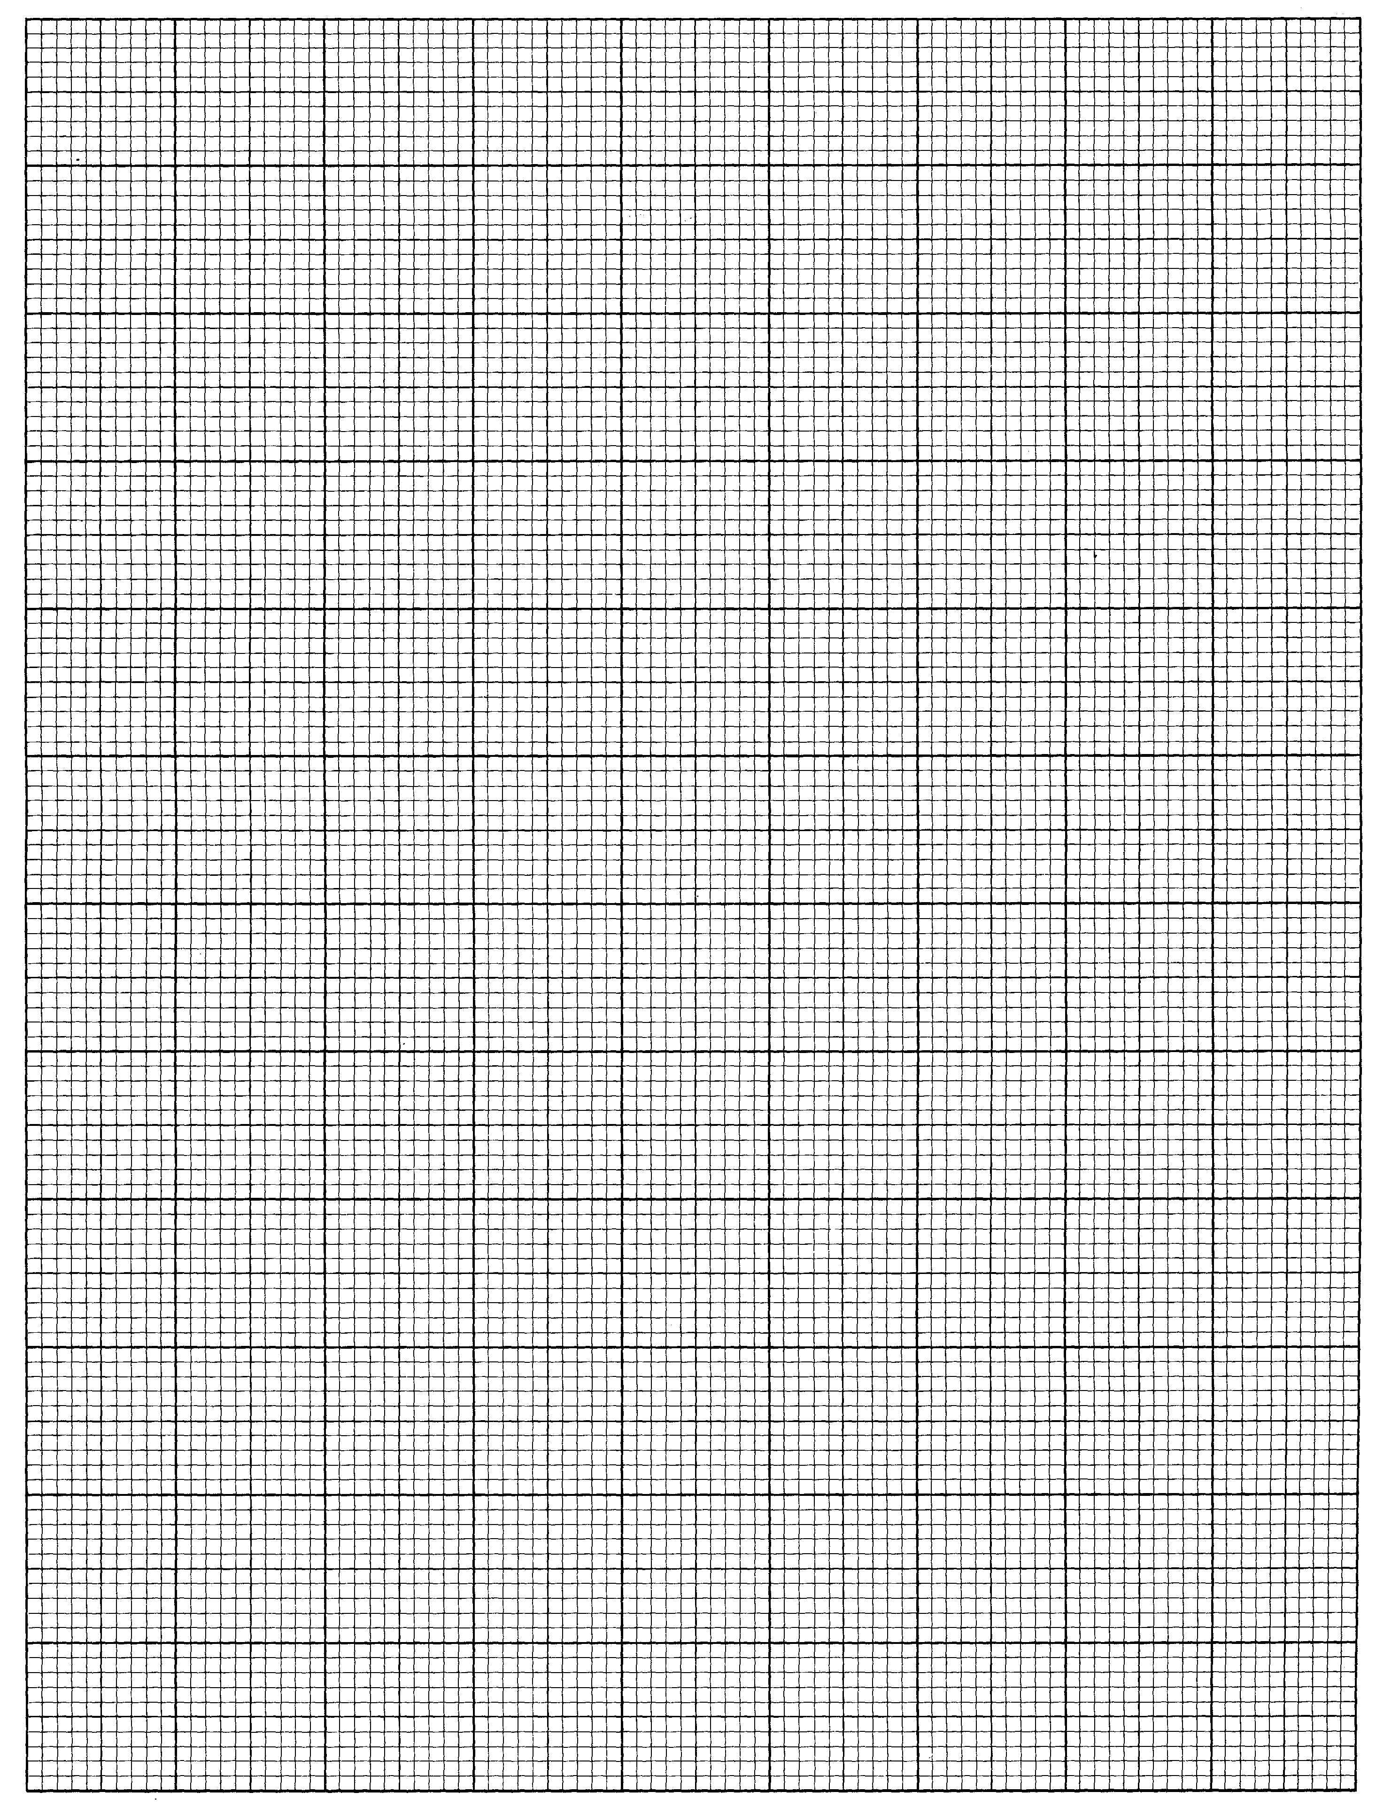
Graf untuk Soalan 14
Kekerapan
Masa
10
2
12
8
4
6
14
16
0
79.5
94.5
124.5
139.5
109.5
64.5
49.5
34.5
18
20

Soalan | Peraturan Permarkahan | Markah
15(a)  (b) | Note:  - Accept drawing only (not sketch)  - Accept diagrams without labels and ignore wrong labels.  - Accept correct rotation of diagrams.  - Lateral inversions are not accepted.  - If more than 1 diagram are drawn, award mark to the correct ones only.  - For extra lines (dotted/dashed or solid) except construction lines, no KN mark is awarded.  - If other scales are used with accuracy of $±$0.2 cm one way, deduct 1 mark from the N mark obtained, for each part attempted.  - Accept small gaps or extensions at the corners.  For each part attempted:  - If 0.1 cm small gaps/extension0.4 cm, deduct 1 mark from N mark obtained.  (ii) If small gaps/extensions > 0.4 cm, no N mark is awarded.  (9) If the construction line cannot be differentiated from the actual lines:  (i) Dotted line  If outside the diagram, award the N mark.  If inside the diagram, award N0.  (ii) Solid line  If outside the diagram, no KN mark is awarded.  (10) For double lines, non –collinear lines, bold lines or crooked lines, deduct 1 mark from the N mark obtained, for each part attempted.  (11) If drawn on graph paper, no KN mark is awarded.  F  H  C  B  E  G  Correct shape with rectangle EHGFand HCBG.  All solid lines,  FB = BC > FG > HC  Measurements correct to $±$0.2 cm (one way) and all angles  at vértices = $\text{90}° ± 1°$  Q  P  E  F  M  R  S  T  H  L  G  B  P  A  Q  F  S  R  i)  H  G  C  R  B  Q  P  E  F  M  R  S  T  H  L | K1  K1  N1  K1  K1  N2  K1  K1  K1  N2 | 12
  Correct shape with prism FGBA and square PQRS.
  All solid lines.
  GB > BA > AF > FG> AP= PQ = QR = RS = SB
  Measurements correct to $±$0.2 cm (one way) and all angles
  at vértices = $\text{90}° ± 1°$
  (ii)
  Correct shape with rectangle BGHC.
  All solid lines.
  (Ignore CR)
  C − R joined by a dashed line to form triangle RCB.
  BC > HC > GR > RB
  Measurements correct to $±$0.2 cm (one way) and all angles
  at vértices = $\text{90}° ± 1°$
Soalan | Peraturan Permarkahan | Markah
16(a)  (i)  (ii)  (b)  (c)  (d) | 105°W  Note :  105º or θº W award P1  50º N  Note :  kos 50º or θº N award P1  6000 n.m  Note :  180° or kos 50° seen award K1  6942.11 n.m  Note :  4800 or (180° - 100°) seen award K1  7 hours 30 minutes | P2  P2  K1  N1  K2  N1  K2  N1 | 4  2  3  3  _  12

SKEMA PEMARKAHAN TAMAT

